Video Number: | V39 | Video Title: | A Wake-Up Call: Why the Nursery is Quiter

- Choice of visuals, visualisation techniques and appropriate use of human visual perception principles

- Line Graph: Total Fertility Rate in Singapore [0:16]
The line graph is an appropriate choice to represent total fertility rate (TFR) over the years, as it effectively communicates temporal trends. Line graphs are particularly effective for showing changes over time as the audience can intuitively trace trends, patterns, and fluctuations in the data.

The author enhances the interpretability of the chart by drawing a red line at the start and the end of the decline in fertility rate and annotating the corresponding values with the same colour. This helps link the annotations with their respective data points, aligning with the principle of proximity and similarity.

Furthermore, the use of a rectangle to highlight the region being discussed draws the audience’s attention to the critical period of decline in fertility rate. The annotation inside the box clearly specifying the reason and the year range of the decline reinforces the visual storytelling. This technique combines both visual salience (highlighting) and textual reinforcement for clarity.

- Multi-Line Graph: Annual Live Births by Ethnic Group [1:20]
At [1:20], a multi-line graph is used to display fertility rates of different ethnic groups using a distinct colour palette. Assigning different colours to each ethnic group leverages the HVP principle of pre-attentive processing, allowing viewers to distinguish categories quickly without conscious effort. The graph also demonstrates relevance, as the amount of information is balanced, not overwhelming nor under-informative.

A suggested improvement is to use a thicker line for the Chinese group to highlight their majority contribution to births, applying the principle of salience. This would help the audience focus on the intended insight without relying solely on colour.

- Line Graph with Symbol Differentiation [1:54]
At [1:54], the line graph uses symbols with distinct shapes and colours to differentiate data points corresponding to the Tiger and Dragon years. This approach aligns with HVP principles such as shape and colour pre-attentive cues, allowing the audience to identify patterns associated with specific years quickly. Using multiple visual channels (colour and shape) reinforces the distinction and improves the cognitive encoding of the data.

- Multi-Line Graph: Total Fertility Rate by Ethnic Group [2:11]
There are frequent overlaps between the lines, especially in years when the fertility rates of different groups are similar. This creates visual clutter and makes it difficult to distinguish the individual trends clearly.

At [2:12], the author states that the Chinese group has the lowest fertility rate among all ethnic groups. This statement is not consistently supported by the data as in some years, other groups such as Indians have lower fertility rates. A more accurate phrasing would be: “Fertility rates vary by ethnic group, with Chinese generally showing lower rates compared to others, though in some years, other groups fall below.”

Additionally, the author could use a boxplot or violin plot to represent the distribution of fertility rates for each ethnic group over the years. To provide further insight, the data could be split into two time periods to examine whether fertility trends have shifted over time. As shown in Figure 1, the violin plot compares the distribution of fertility rates among different ethnic groups across two time periods. For instance, the violin plot shows that while the Chinese group generally maintains the lowest fertility rates overall, the Indian group occasionally overlaps with or falls below the Chinese group in certain years. This indicates that although the Chinese group tends to have lower fertility rates on average, there are specific periods where the Indian group experiences even lower rates.

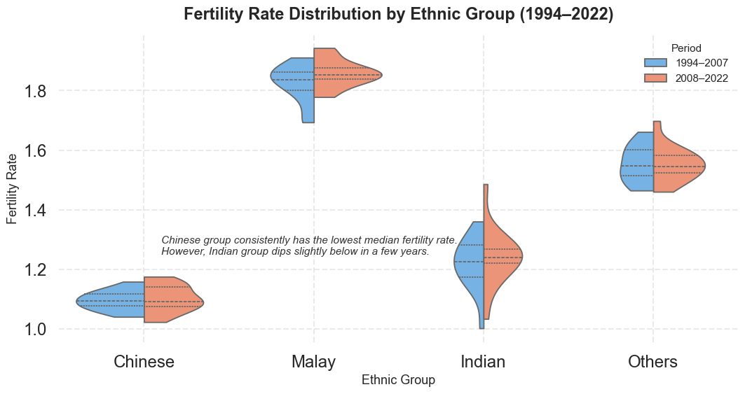
Figure 1: Violin plot of total fertility rates by ethnic group and period

- Boxplot: Synthetic Distribution of Age at First Birth by Ethnic Group [2:19]
The boxplot at [2:19] is designed to represent age distributions. While the boxplot is an appropriate choice for summarising distributions, the Y-axis uses a 2.5 tick interval, which is unusual for age data, as ages are typically represented using whole numbers. This design choice may confuse the audience and make precise interpretation difficult. Adding grid lines would improve readability and allow viewers to estimate values accurately.

The title indicates that the data is synthetic, which is appropriate for demonstration purposes. Yet, it might be helpful if the author clearly mentions that the dataset is synthetic, so viewers are aware that it does not represent real population trends. This small clarification would enhance transparency and help prevent any possible misunderstanding.

- Multi-Line Graph: Age-Specific Fertility Rates Over Time [2:24]
When discussing specific age groups, the author could use slide design tools to highlight the relevant lines, making them more visually prominent and easier for viewers to follow. To emphasize the overall decline across all age groups, additional visual cues such as arrows could be applied to draw attention to the trend effectively.

At [2:45], a blue dotted vertical line is annotated to indicate a turning point, but the author only discusses the top two lines, which may confuse viewers. A better approach would be to circle the turning point or use an arrow annotation to clearly indicate when 30s fertility overtakes 20s fertility.

- Composition Bar Chart: Age-Specific Fertility Composition [2:55]
Bar charts showing the proportions of total fertility by age group are an appropriate and effective choice for visualizing the data. The use of colour coding to represent distinct age groups aligns with the principle of similarity, enabling viewers to quickly and intuitively differentiate between categories. This visual approach helps highlight which age groups contribute most significantly to overall fertility trends. Additionally, the proportional representation allows for easy comparison across years, making it clear how fertility patterns have shifted among younger and older age groups over time.

- Multi-line Graph: Graduates from University by Type of Course and Sex [3:00]
The multi-line graph comparing male and female university graduates at [3:00] suffers from frequent overlap. Both lines increase over time, and the data points for male and female graduates are often close, making it difficult to discern trends for each gender.

The following adjustments can be considered for improving the multi-line graph:

- Use different line styles to differentiate trends without relying solely on colour. For instance, solid for male and dotted for female as shown in Figure 2.
- Use slight transparency for line visual marks so that overlapping regions are visible.
- The author can consider using a stacked area chart as shown in Figure 3 to highlight relative contributions of each gender while preserving temporal trends.

Besides that, the title of the graph suggests that it shows graduates by type of course and sex, but the visualization only displays the number of graduates by sex (male and female) across years. The discrepancy between the title and the actual data presented may confuse viewers. Therefore, the title could be revised to “Number of University Graduates by Gender (1994–2022)” for greater clarity and consistency with the visualized data.

In terms of presentation design, an animated arrow in green can be used to show the increasing trend of university graduates for both genders.

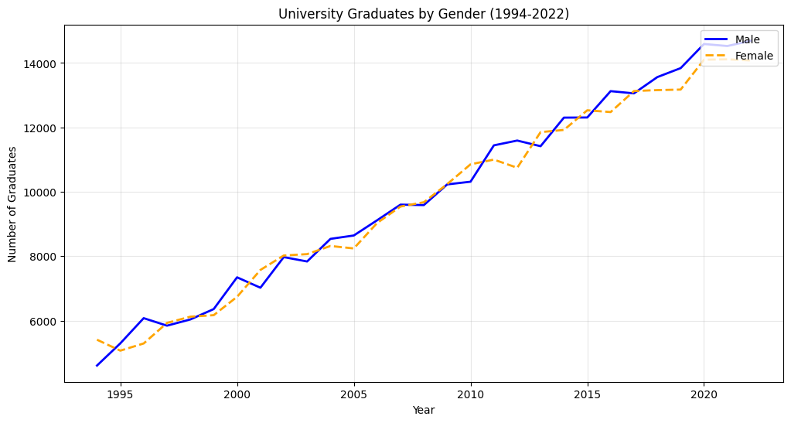
Figure 2: Line style variation for number of university graduates by gender

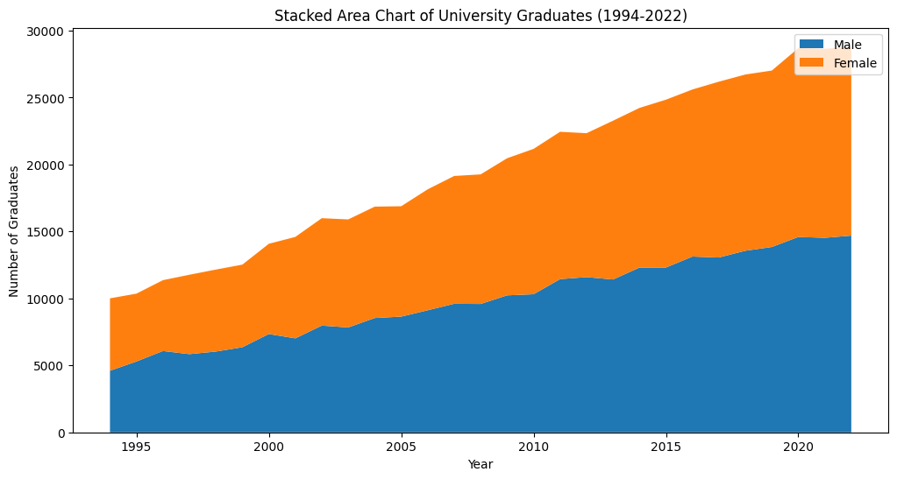
Figure 3: Stacked area chart of university graduates over time

- Overall Comments

The strongest feature of the video presentation is its clear and engaging storyline, which effectively addresses the question of “Why the Nursery is Quieter”. For example, the first line graph effectively conveys total fertility rate over time, with clear annotations and highlighted regions that draw attention to important trends. Another standout is the Dragon vs Tiger year graph, which creatively uses different symbols on the line graph to differentiate the years. This use of shape and colour as pre-attentive visual cues is both visually appealing and informative, allowing the audience to quickly identify patterns without confusion. Overall, these elements show thoughtful application of visual design principles and make the data story compelling and memorable.

The weakest aspect of the presentation lies in inconsistencies in graph design and limited annotations, which can reduce clarity. Some graphs use a light grey background instead of white, making certain colours, such as fluorescent yellow, difficult to see. In addition, many of the multi-line graphs lack annotations, which makes it challenging for the audience to identify key trends or differences between groups. These issues increase cognitive load and may hinder interpretation of the data.

Overall, the presentation is effective in delivering a coherent and engaging story. However, improving design consistency, colour contrast, and annotation would enhance clarity and make the visual narrative more precise, allowing the audience to better understand the factors contributing to the quieter nursery.

